Dear Families

Great News!
- Students can log in to DayMap at home
- Parents/Caregivers can log in to the DayMap Parent Portal

DayMap, a system Victor Harbor High School has adopted for recording attendance and Learner Management (reports, assessment, homework, lesson plans and class notes) is now available to students and families outside of the school. DayMap works best on Internet Explorer but will work with other web browsers.

Students can use the following url to log in to DayMap at home, just as they would at school. They can check assessment tasks, lesson plans and homework as well as see results that teachers have published including mid-term and end of term reports.
Students:
- Type the following address into the address bar: https://daymap.vhhs.sa.edu.au/daymap
Alternatively there is a link to this page on our website: http://www.vhhs.sa.edu.au

- You will then get the following message – don’t worry about this – just click on “Continue to this website”
- Students will then be asked to enter their username and password. These are the same as they log in to the school computers with.

Families:
Victor Harbor High School has had the DayMap Parent Portal running for more than a year. This provides families with real time information about their children’s attendance, assessments, homework and more. In 2015 and beyond the parent portal will be where interim reports, term reports and semester reports are posted.

The Parent Portal is a secure online web application that can be accessed through the internet. Families will need access to the internet and the url provided below.
In order for access to occur Victor Harbor High School will need to have one current email address from one parent/caregiver. Once this is clarified and configured families can use the instructions below to access the parent portal.

The purpose of this letter is to:
- Ensure that we have the correct contact email on our records
- Explain the instructions for you to access the parent portal

- PLEASE ENSURE WE HAVE YOUR CURRENT EMAIL ADDRESS
If you need to confirm or change your email contact address by contacting the school on 8551 1900, select option 1 – Student Services and talk with our friendly staff who will update our records for you.

- INSTRUCTIONS FOR ACCESSING THE PARENT PORTAL

Once your current email address is confirmed with us and configured – the following steps will assist you to gain access to the parent portal:

- Using Internet Explorer (it works best on this browser) type in the following url into the address bar

http://daymap.vhhs.sa.edu.au/DayMapConnect
Alternatively there is a link to this page on our website: http://www.vhhs.sa.edu.au
The instructions of how to access Daymap are shown on the youtube video link below the DAYMAP PARENT LOGIN button on the VHHS website.
Youtube Link: https://www.youtube.com/watch?v=gYhtxYebJrU&list=PLHiPMO1JuOKtxHXFUlUnO8AvWomb--kjY&index=6

- You will then get the following message – don’t worry about this – just click on “Continue to this website”

- You will then get the following welcome screen:
The first time you use the parent portal you will need to click on New User?

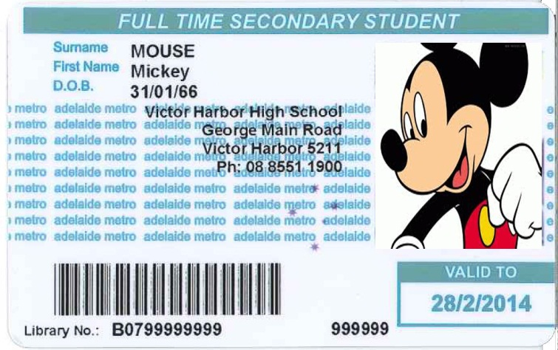
- Next you will need to enter the confirmed email address you have registered with Victor Harbor High School and the student code of ONE of your students you have enrolled at the school. You will find the student code on your child’s student ID Card:

- Once you have clicked the Reset Password button, an email will be sent to the email entered providing you with a username and a password. CHECK YOUR EMAIL

- Once you have your username and password from your email you will need to go back to the first screen (shown again below) and enter the username and password you have been given and click the Sign In button.
Once in the portal, it is easy to navigate between Timetable, Attendance and Results
The Timetable page shows the classes the student is enrolled in and also a quick glance at whether the student has attended classes
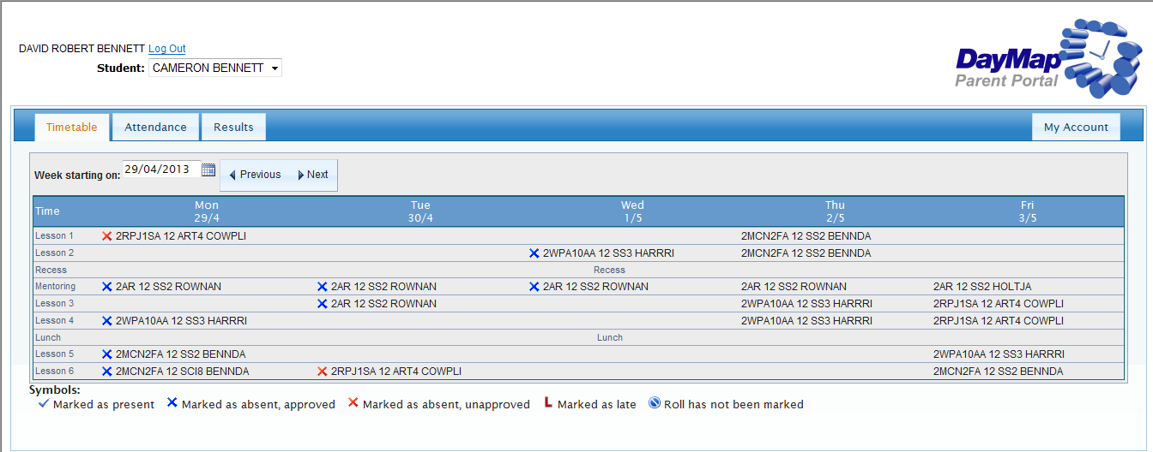
Families with more than one student enrolled at VHHS will be able to toggle between each student
STUDENT NAME
PARENT NAME
The Attendance page show an attendance map – hovering over the coloured boxes will show more information for that day – and attendance rates for each of the classes the student is enrolled in. It is important to remember that our target for attendance is 95% or better!
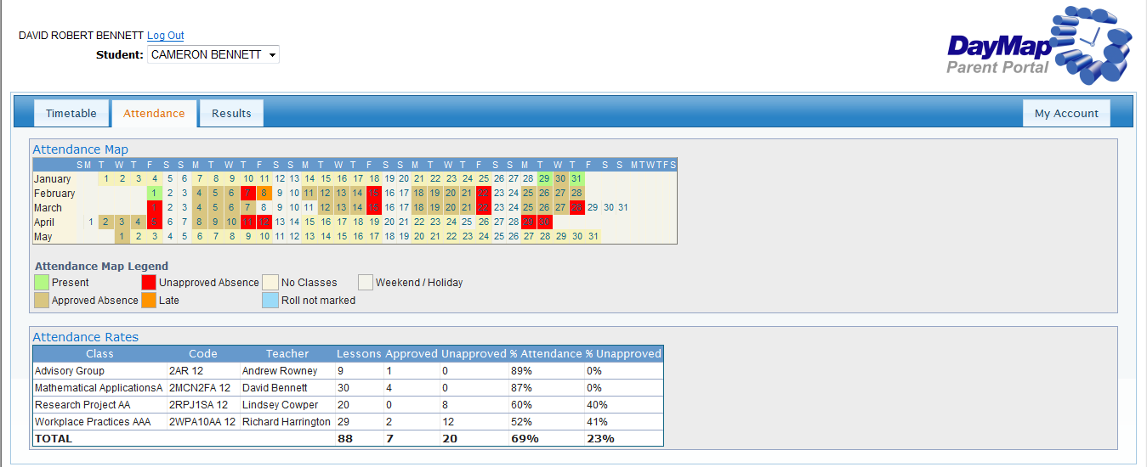
Teacher One
Teacher Two
Teacher Three
Teacher Four
Mentoring Group
Maths
English
Science
STUDENT NAME
PARENT NAME
The Results page will show student reports when published. We have just published Term 1 reports and this should be available by clicking Outcome Based toggle and choosing the report that is relevant (i.e. Middle School Report, Stage 1 Term 1&3 or Year 12).
Comment from teachers will appear here

PARENT NAME
STUDENT NAME
If you have any difficulties in using the Parent Portal please contact our Student Services or myself directly. I hope you enjoy using this tool in working with the staff of Victor Harbor High School in striving for young people to achieve their full potential.

Yours Faithfully

David Bennett
Assistant Principal
ICT Coordinator

